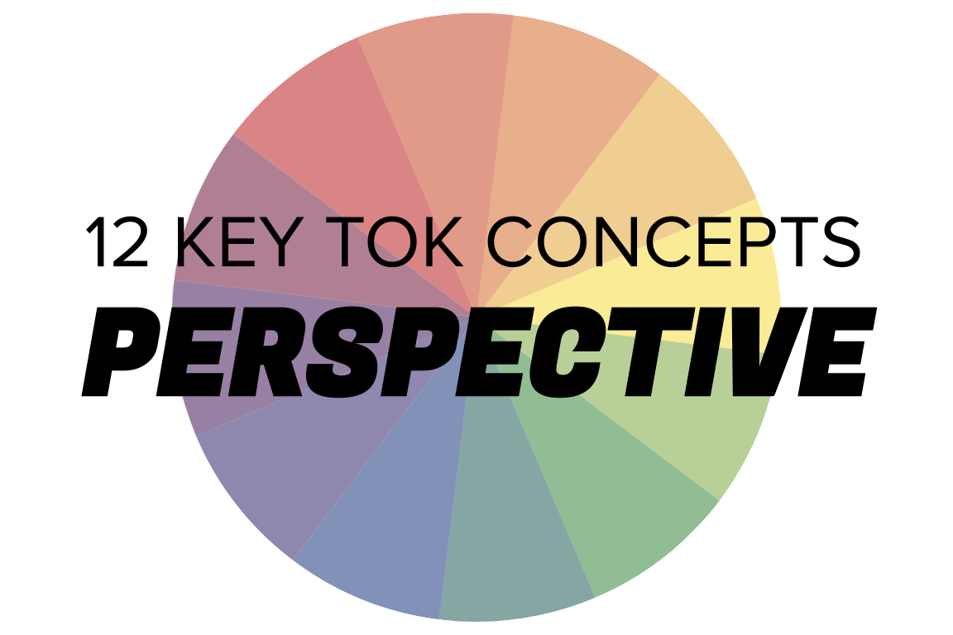 | PERSPECTIVE

Understanding the 12 key concepts
- The 12 key concepts are ones that have been identified as having a particular significant relationship to knowledge.
- Understanding, exploring, and using these concepts will help you to understand the way knowledge is produced and used, within the core and optional themes, and the areas of knowledge.
- You should also try to use the key concepts as extensively as possible in the two TOK assessment tasks.
Starting points for perspective  - How many online definitions can you find for ‘perspective’?  - Which one do you think best sums up this concept, and why?  - Which of the quotes below do you think provides us with the best insight into perspective? Are there any you disagree with?  - How would you summarize your perspective when it comes to knowing? | Quotes on perspective  - Science is a way of life. Science is a perspective. Science is the process that takes us from confusion to understanding in a manner that's precise, predictive and reliable - a transformation, for those lucky enough to experience it, that is empowering and emotional. Brian Greene  - Truth can be a matter of perspective, but I also think there's a truth that exists, that there are laws to the universe the way Gandhi and Dr. Martin Luther King believed. Tom Shadyac  - Each person does see the world in a different way. There is not a single, unifying, objective truth. We're all limited by our perspective. Siri Hustvedt  - It's useful to go out of this world and see it from the perspective of another one. Terry Pratchett  - Academics lack perspective. In a debate on whether the world is round, they would argue, 'No,' because it's an oblate spheroid. They suffer from 'the curse of knowledge': the inability to imagine what it's like not to know something that they know. Steven Pinker  - Perspective is not a science but a hope. John Berger
Interlinking the key concepts  - What role does culture play in determining our perspective?  - Do different perspectives always lead to different interpretations?  - Do our explanations depend on our perspective?  - Does truth depend on our perspective?  - Can there ever be any certainty given that everyone has a different perspective? | Relating perspective to the TOK course  - Which of the areas of knowledge are most and least affected by different perspectives?  - How do our religious and political perspectives shape the way we view the world?  - How different is an indigenous perspective to knowing about the world?  - Do our perspectives determine our language use?
Relating perspective to the TOK exhibition  - IAP-2: Think about whether our perspective shapes the type of knowledge we consider useful  - IAP-9: Think about how a knower’s perspective might shape the way they interpret knowledge  - IAP-12: Think about whether our perspective may make bias inevitable  - IAP-14: Think about whether the knowledge community to which we belong possesses certain knowledge about the world  - IAP-26: Think about how interacting with other knowers and their perspectives affects our knowledge | Relating perspective to the Big Questions  - BQ1 - What are perspectives?  - BQ2 - What is the moral impact of a reluctance to step outside of one’s own perspective as a knower?  - BQ3 - How does our perspective influence the way we communicate knowledge?  - BQ4 - Do our perspectives shape the way we understand the world?  - BQ5 - How do the perspectives of knowers change over time?  - BQ6 - Do expert knowers always manage to transcend their perspectives?

Real-world contexts for perspective
The media sources below explicitly mention perspective, and discuss this key concept in a real-world context. Use the find command (ie Command/Control+F) to locate the term in the article or transcript of the video, and you’ll see where it features. Check back regularly, as we update these media sources every month.
Big Question / knowledge framework | Description of media source and story and links to the course
BQ1 / Nature & scope | A Conversation article, which considers the paradox of Norway and Finland having similar levels of gun ownership to the US, but far less gun crime. Human sciences, Politics  A Big Think article, looking at the McGurk Effect, an auditory illusion which even when we are aware of, still misleads our brains. Knowledge & the knower, Religion  A Big Think article, looking at how some video games - such as The Last of Us II - qualify as great art because they give us a profound insight into the human condition. The arts, technology  Brian Resnick at Vox looks at the effect that relying on photographs to help us remember places and events has on our capacity to remember. Technology, knowledge & the knower  This is a demanding Aeon essay, but it’s also a brilliant one, looking in a great deal of detail about science, and its relationship with ‘truth’ (whatever that means). Natural sciences, human sciences, religion
BQ2 / Values | A Guardian article and photo gallery, showing what pregnancy tissue from 5 to 9 weeks actually looks like. Natural sciences, Politics, Religion  An Aeon essay, considering the extent to which we should rely on empathy to achieve objectivity. Knowledge & the knower, Human sciences  A Conversation article, looking at how the Scottish government has apologized for executing witches in the 16th century. History, Human sciences, Religion
BQ3 / Methods & tools | A BBC article, exploring the relationship between language and the way we perceive time. Language, Knowledge & the knower  A Smithsonian article, looking at a 1945 Holocaust comic that tried to communicate the horrors of the Nazi death camps. Language, History, The arts, Knowledge & the knower
BQ4 / Perspectives | A Conversation article, pointing out that contrary to common media reports, the majority of people in the US trust scientists and science. Natural sciences, Human sciences  A Conversation article, analyzing how people from both sides of the political spectrum only detect bias when it supports the opposing party. Politics, Knowledge & the knower, Human sciences  A New Arab article, looking at the non-appearance of Iran’s President at an interview with a headscarf-less reporter. Religion, Politics, Human sciences  A Salon article, arguing that the term ‘feminist science’ is not an oxymoron, and offers a powerful set of tools for examining knowledge. Natural sciences, Knowledge & the knower, Politics  A Big Think video, in which Francis Collins argues that science and religion are asking very different questions. Religion, Natural sciences, Knowledge & the knower  A Conversation article, exploring how different cultures have a different understanding of what constitutes being a person. Indigenous societies, Religion, Human sciences, Natural sciences, Knowledge & the knower  A BBC article and video, looking at the way President Zelensky adapts his language and message according to the audience he is dealing with. Language, Politics, Human sciences  A History Today article, looking at how the conflict between Russia and Ukraine is as much about the past as it is about the present. History, Politics  An Aeon essay, looking at six different narratives of the nature and effect of globalization. Human sciences, History, Politics, Technology  A short History Today article, looking at EH Carr’s famous assertion that historians “fish for the truth”. History, Language  An NBC article, discussing the implications of laws in the US designed to ‘balance perspectives’, and how this will impact on the teaching of topics such as the Holocaust. History, Human sciences  A Conversation article, looking at how our judgement of when life begins is as much a matter of politics as it is about science. Politics, Natural sciences, Religion, Human sciences  A Smithsonian article, which looks at how mosquitoes played a critical role in human history. History, natural sciences, technology  This Atlantic article examines the work of Arielle Baskin-Sommers, a Yale researcher, who spent time investigating prisoners with psychopathic tendencies in a maximum-security prison in Connecticut. Her particular focus was to try to understand how able they are at considering the thoughts of others – known as ‘perspective taking’. Human sciences, knowledge & the knower
BQ5 / Methods & tools | A Conversation article, questioning whether ‘nudge theory’ is really as effective as its proponents argue. Human sciences, Mathematics, Language  Vox and Conversation articles, looking at this year’s winner of the Nobel Prize for biology, and what it reveals about sense perception. Natural sciences, Technology  A Smithsonian article, looking at the ‘Oregon Trail’ video game, and how it has developed since it was first released back in the 1970s. Indigenous societies, history, technology, the arts  An Aeon essay, considering how the Aztec people approached history, and how for them, truth was ‘composite’. History, indigenous societies, language  A Smithsonian story, looking at the way a doctoral student, Alice Lee, debunked the widely accepted theory that cranial capacity determined intelligence in the late 19th century. Human sciences, indigenous societies, knowledge & the knower
BQ6 / Methods & tools | A Conversation article, which looks at a film about indigenous stories about the night sky, and how they help us to comprehend the universe. Indigenous societies, Natural sciences, The arts, Religion, Politics  An Aeon essay, looking at the relationship between certainty and expertise about knowledge. Knowledge & the knower, human sciences

